**LABORATORIES**

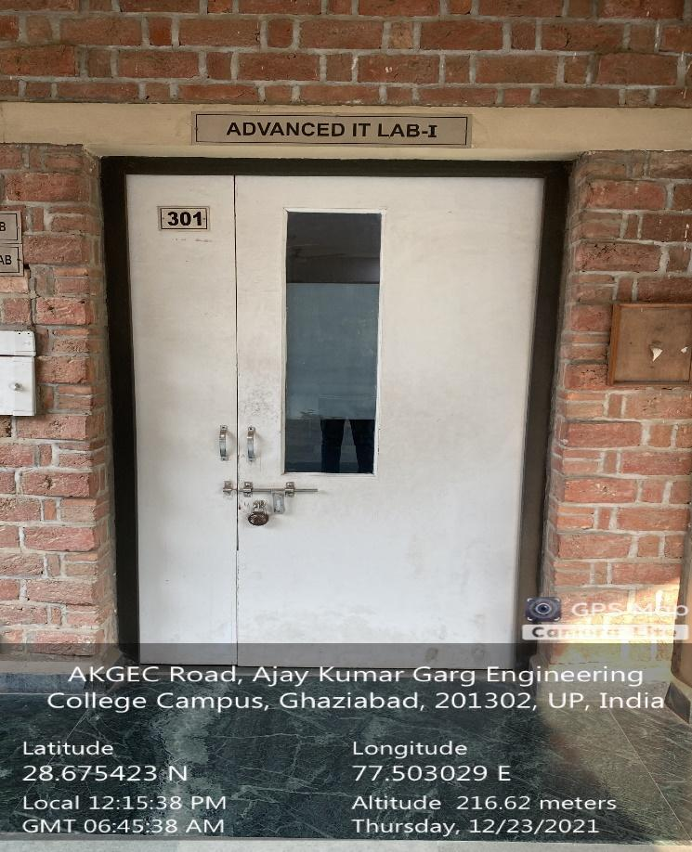

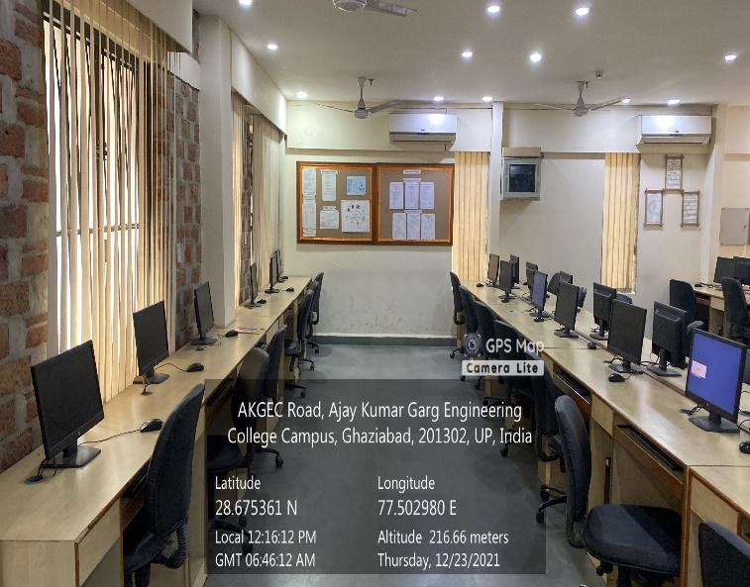

**CSIT BLOCK, 3RD FLOOR, DBMS LAB**



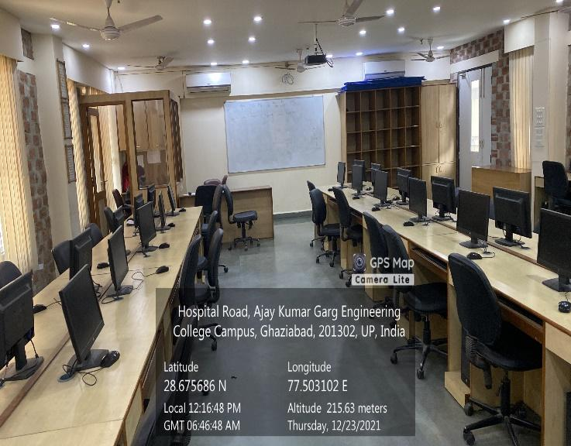

**CSIT BLOCK, 3RD FLOOR, ADVANCE IT CNS LAB**

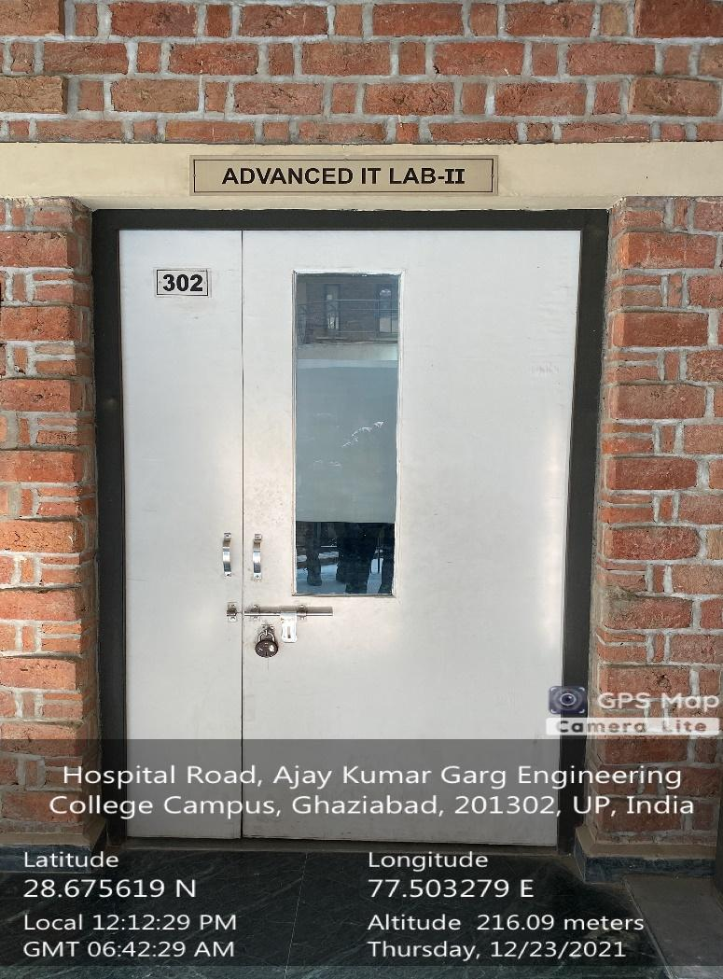

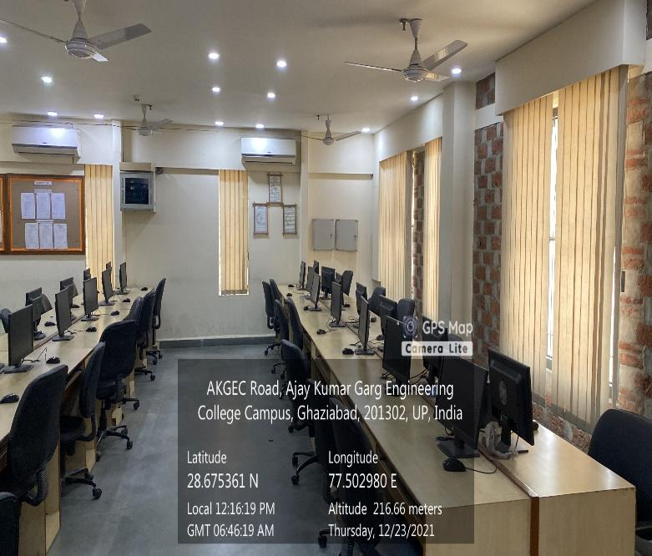

**CSIT BLOCK, 3RD FLOOR, DATA STRUCTURE LAB**

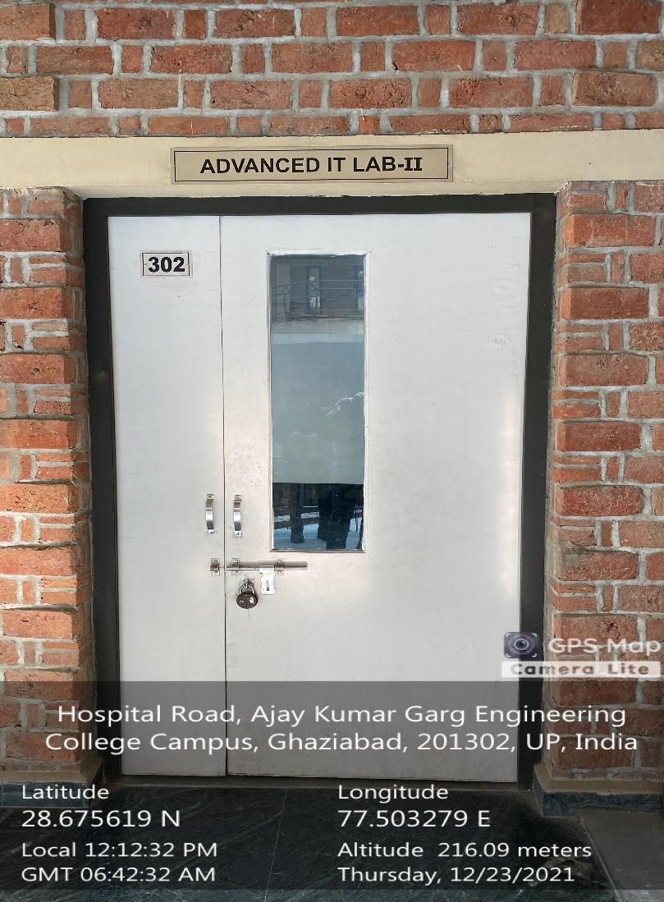

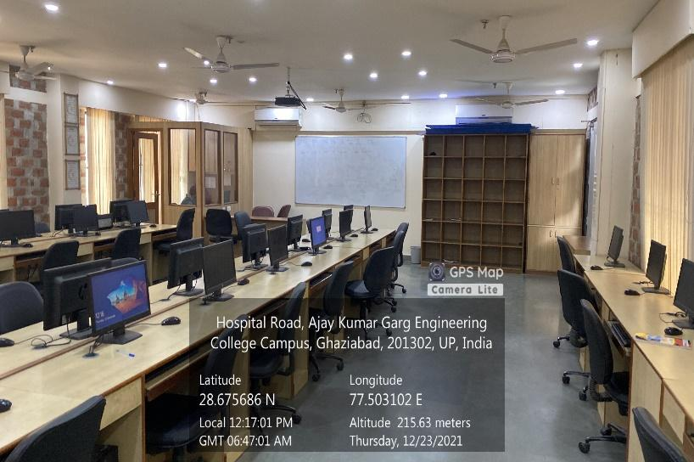

**CSIT BLOCK, 3RD FLOOR, DATA MINING LAB**

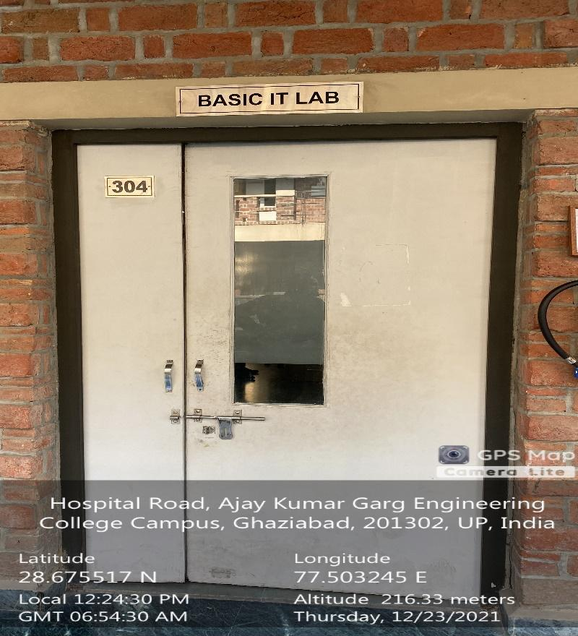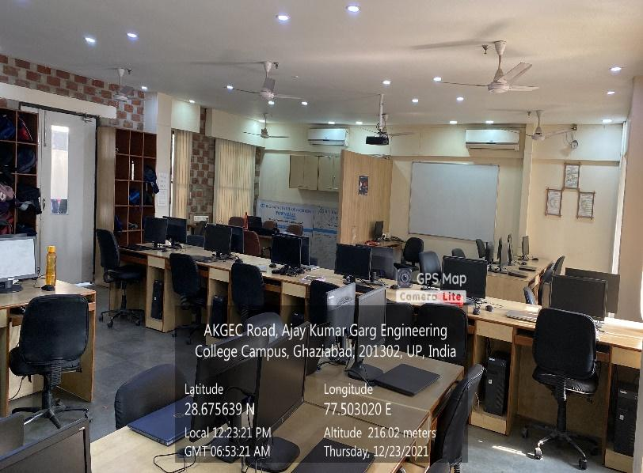

**CSIT BLOCK, 3RD FLOOR, PPS LAB**

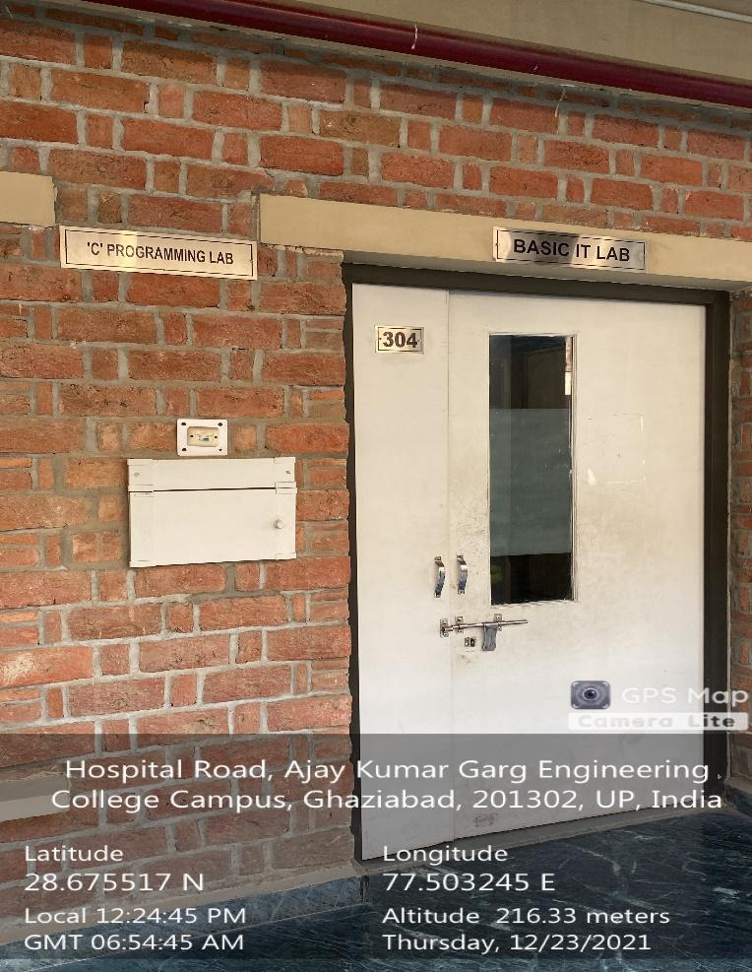

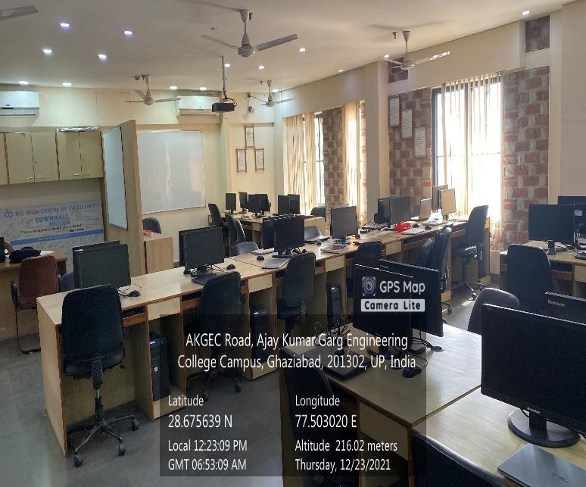

**CSIT BLOCK, 3RD FLOOR, PYTHON LAB**

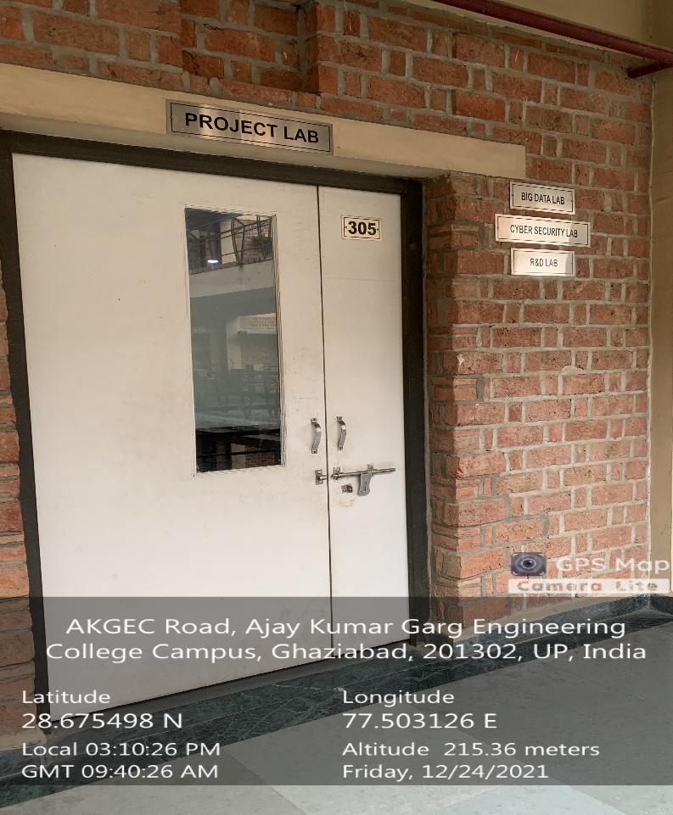

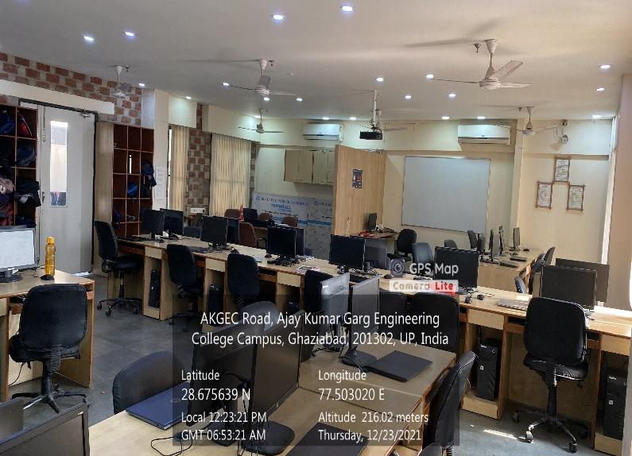

**IT PROJECT LAB MINI PROJECT LAB**



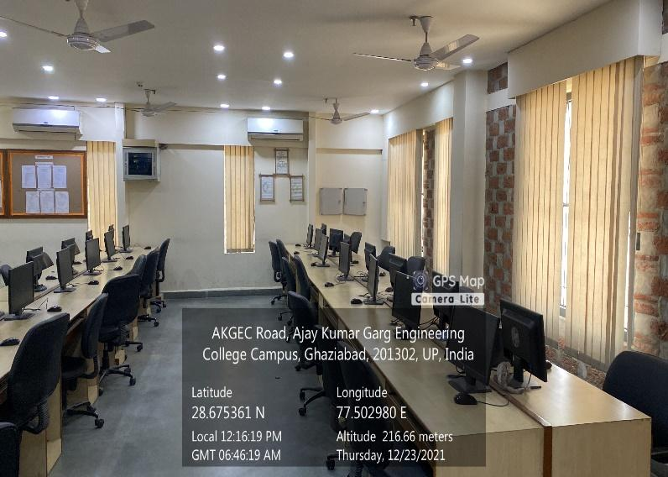

**IT PROJECT LAB**

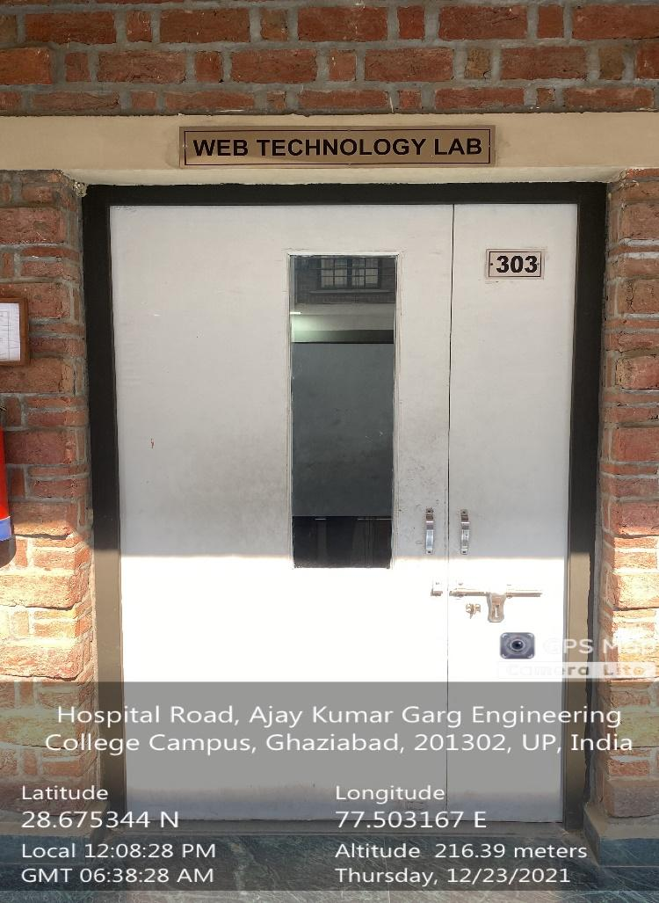

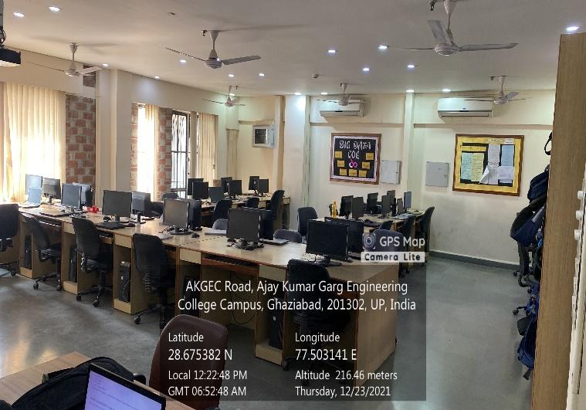

**WEB TECHNOLOGY LAB DAA**



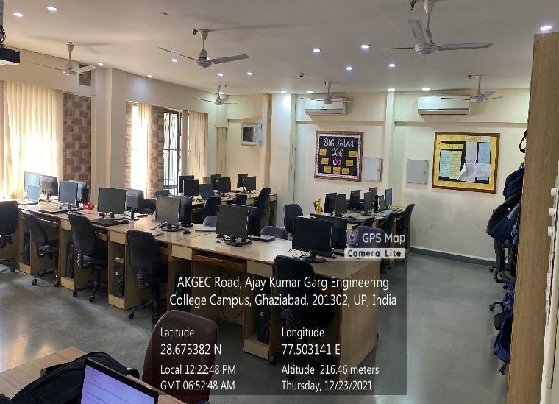

**WEB TECHNOLOGY LAB**